Steps to properly install the MySQL connector for VS2017
Dated 10/03/2019

You will need....
MySQL Connector 1.1.12 @ https://dev.mysql.com/downloads/connector/cpp/
under Previous GA version
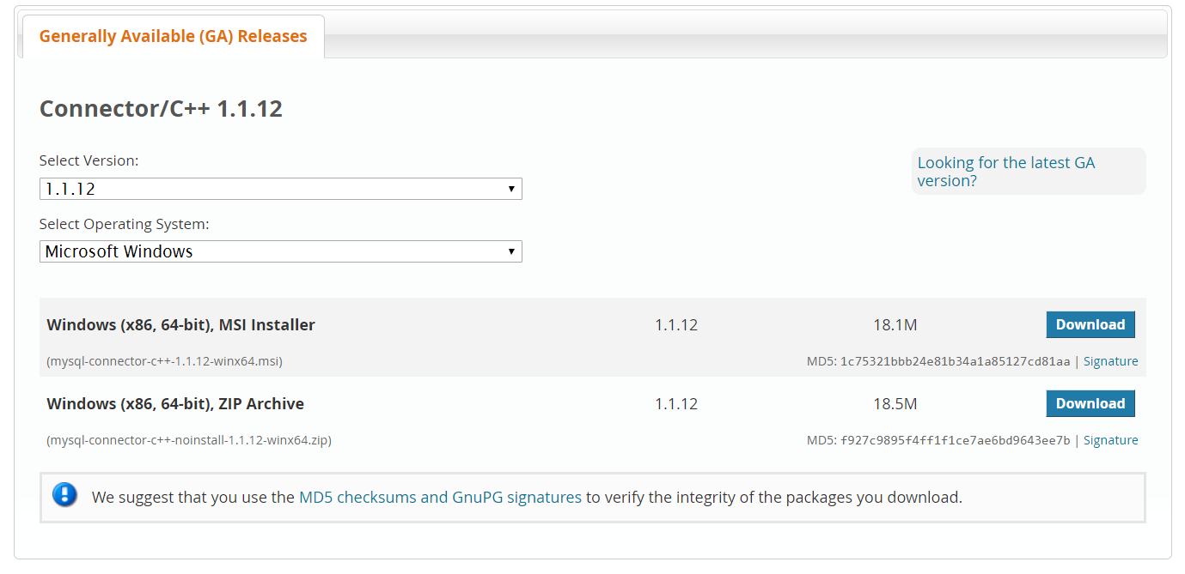
and MySQL Workbench (Using latest version as of this document)
@ https://dev.mysql.com/downloads/workbench/
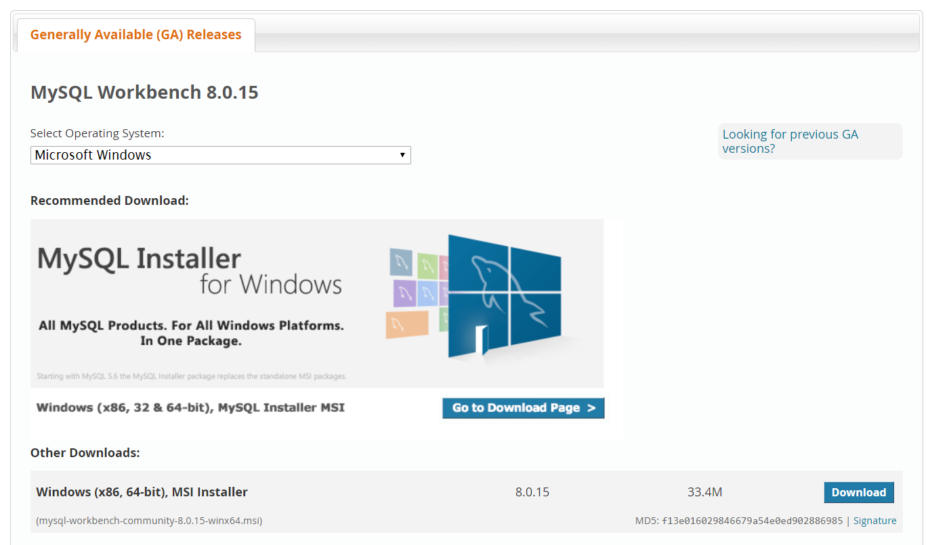

Note: ALL INSTALLATIONS ARE “DEFAULT” WITHOUT CUSTOM PATHS.

1. Under project properties, set the solution configuration to “Release”. The connector will NOT work otherwise. Solution platform MUST also be 64 bits.

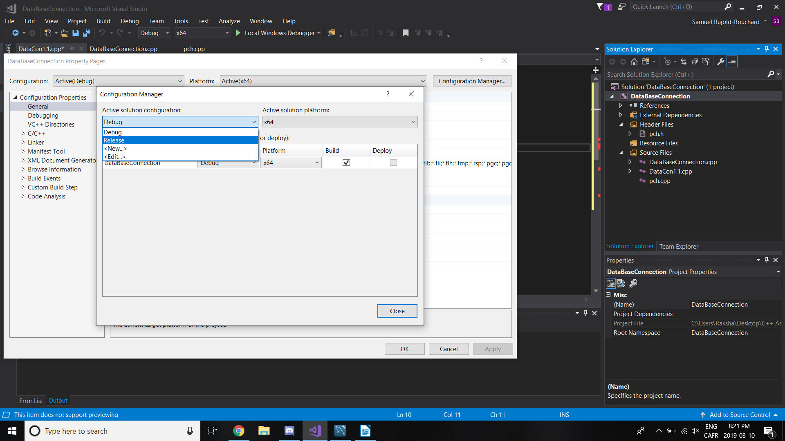

2. Select ALL Configurations
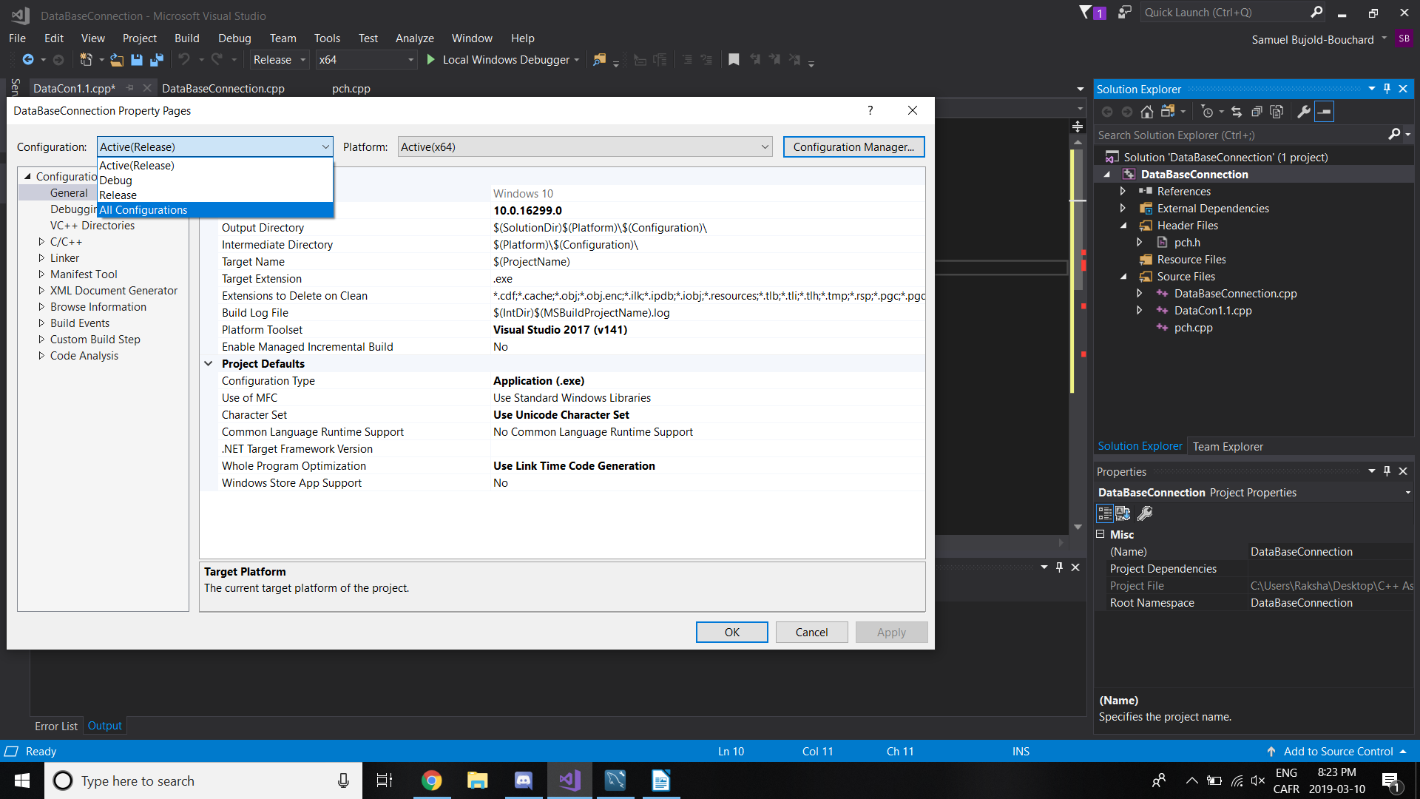

3. Include relevant include and lib directories (Order matters!)

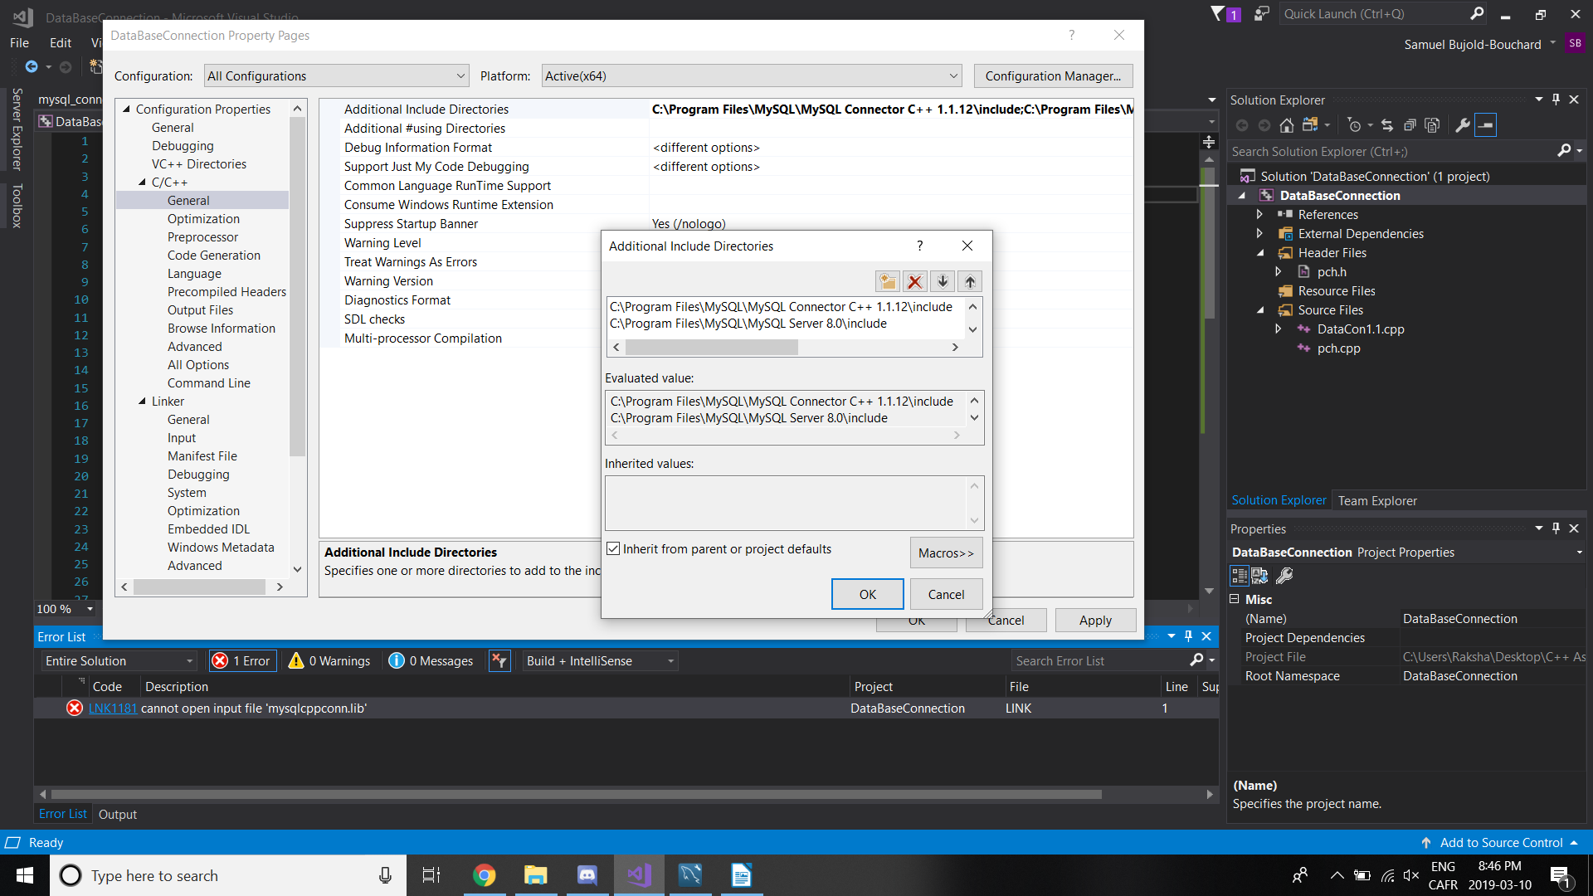
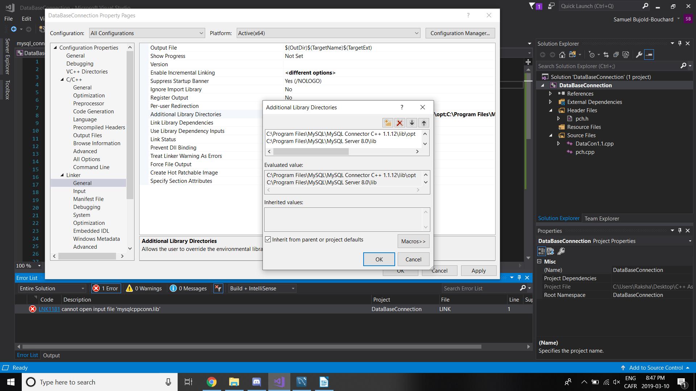

These are default installation directories for both MySQL Server and the Connector:

C/C++ General
C:\Program Files\MySQL\MySQL Connector C++ 1.1.12\include
C:\Program Files\MySQL\MySQL Server 8.0\include

Linker General
C:\Program Files\MySQL\MySQL Connector C++ 1.1.12\lib\opt
C:\Program Files\MySQL\MySQL Server 8.0\lib

4. Include Linker Dependencies:

Linker Input
mysqlcppconn.lib
libmysql.lib

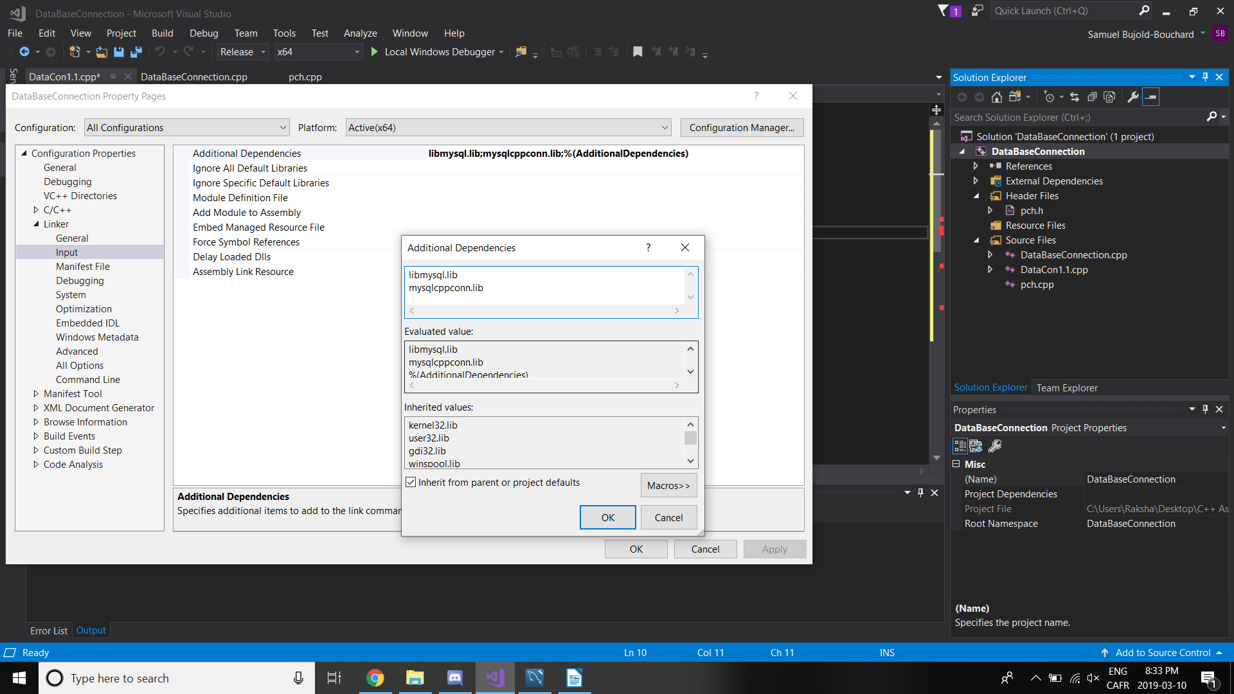

5. At this step, your solution should no longer have errors.

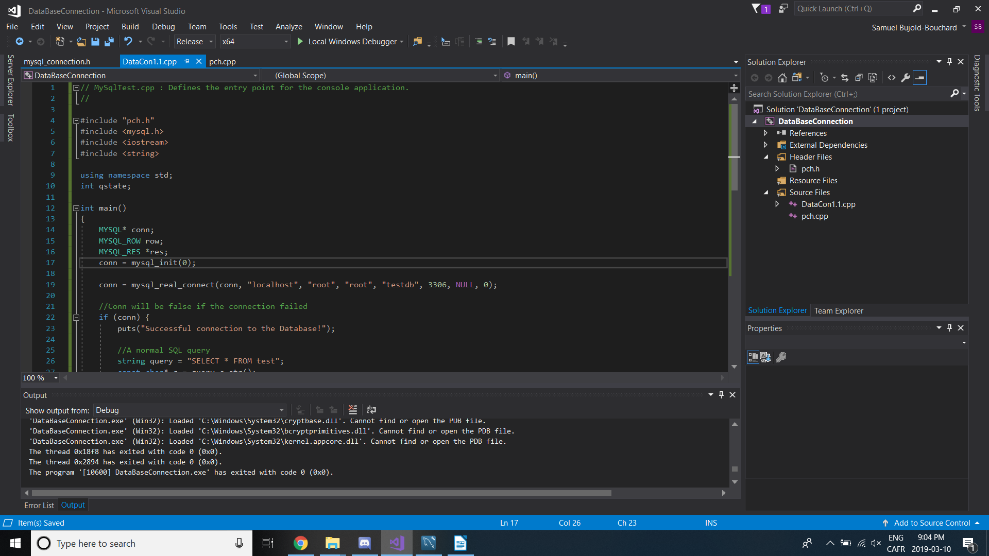
However! The build will not run until the proper documents are added to the solution.

6. Copy .dlls

Copy libmysql.dll from C:\Program Files\MySQL\MySQL Server 8.0\lib
Copy libeay32.dll from C:\Program Files\MySQL\MySQL Server 8.0\bin
Copy ssleay32.dll from C:\Program Files\MySQL\MySQL Server 8.0\bin
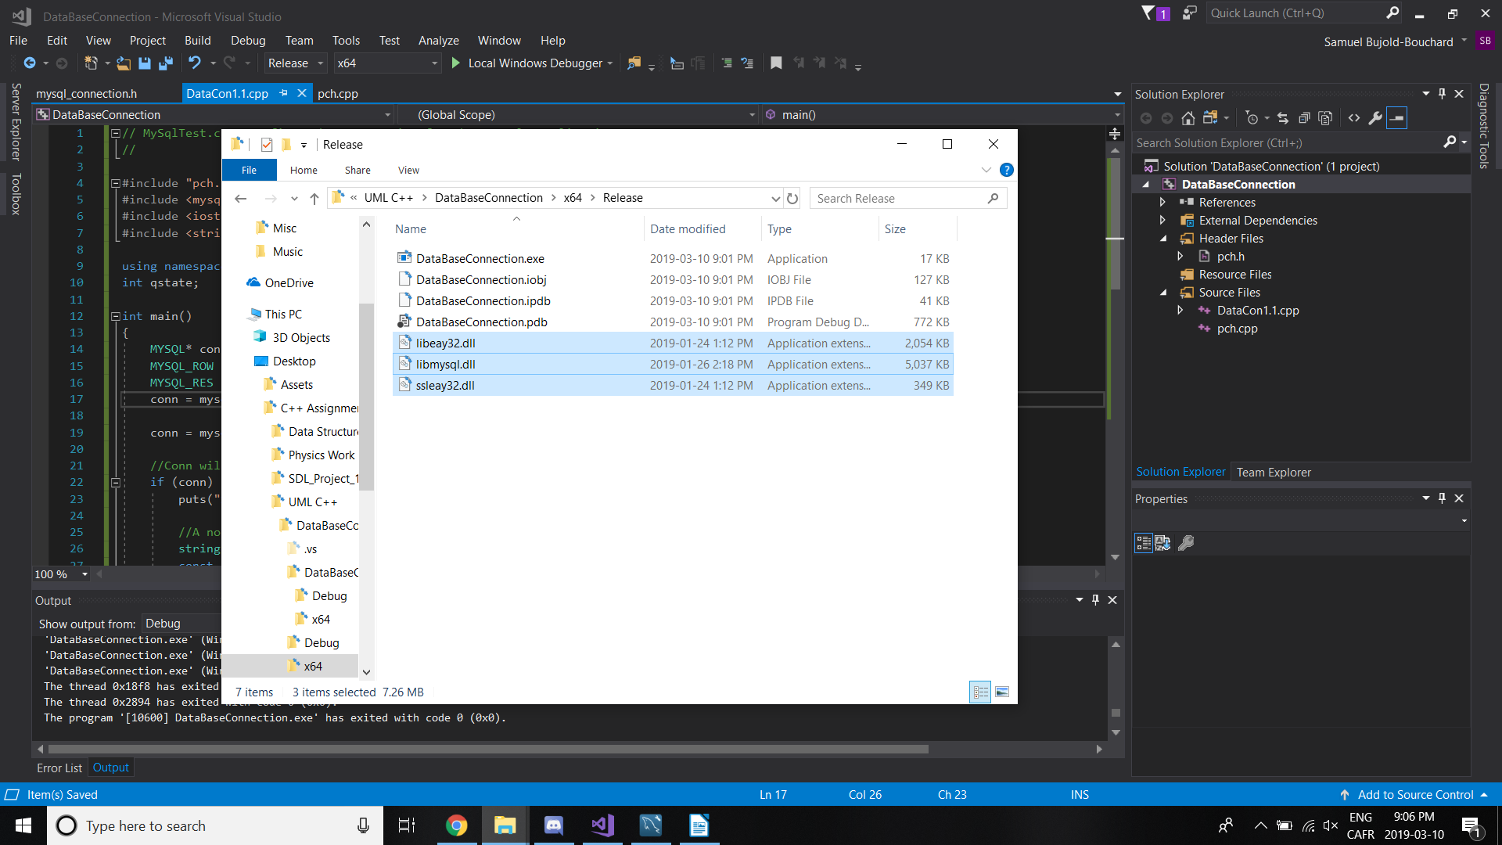
to the executable directory

7. Run the solution!
